**TASK REPORT**

**WEB PROGRAMMING**

**WEEK 1**

**Created by:**

**Cesario Hafidh Arifa Noorcholish**

**L200224217**

**X**

**INFORMATICS ENGINEERING**

**FACULTY OF COMMUNICATION AND INFORMATICS**

**UNIVERSITAS MUHAMMADIYAH SURAKARTA**

**2023/2024**

**TASK**

1. **Experiment 1 (HTML Document)**

* Code

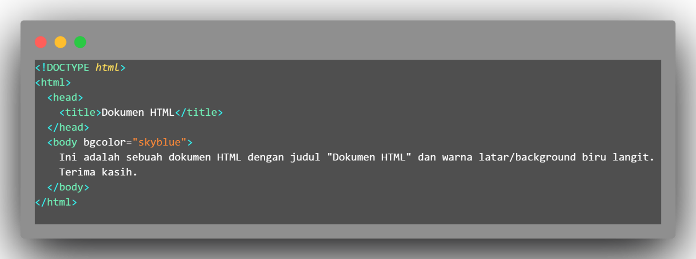

* Result

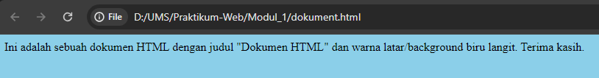

1. **Experiment 2 (Heading)**

* Code

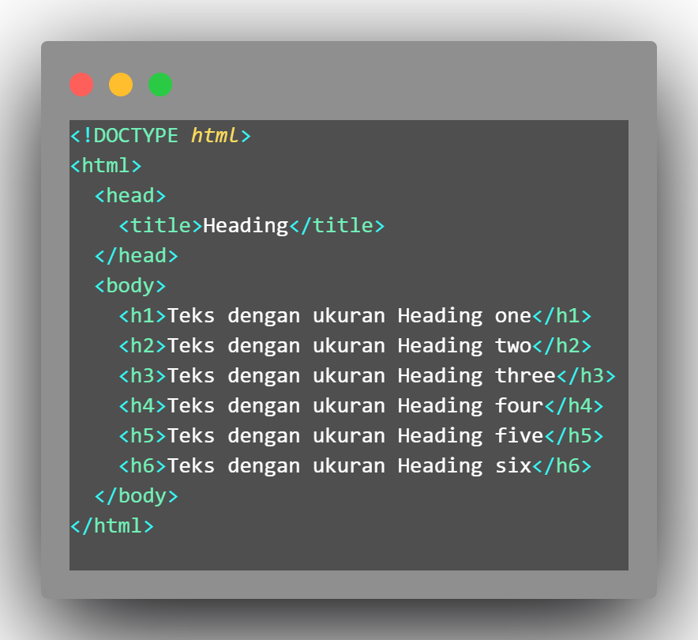

* Result

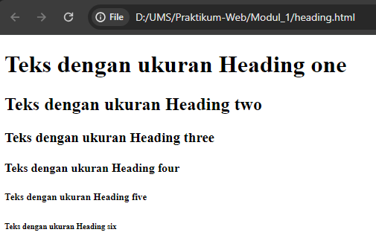

1. **Experiment 3 (Font)**

* Code

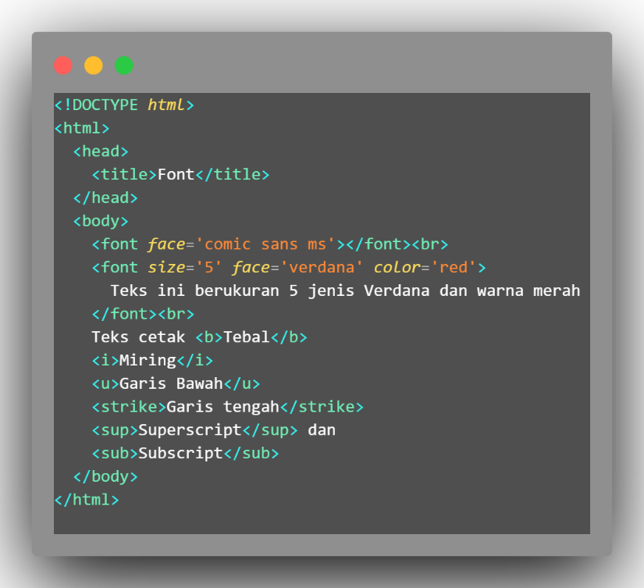

* Result

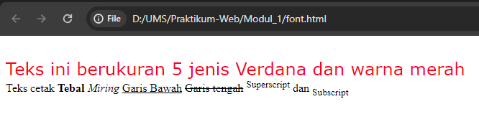

1. **Experiment 4 (Paragraph and Alignment)**

* Code

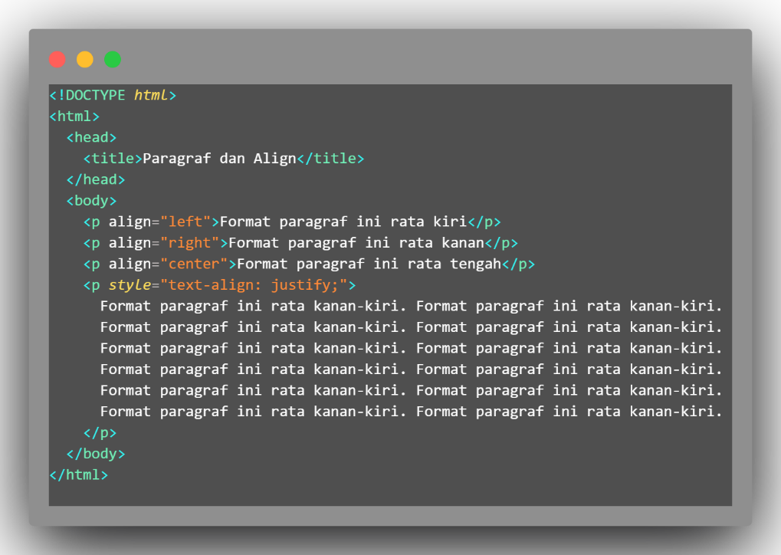

* Result

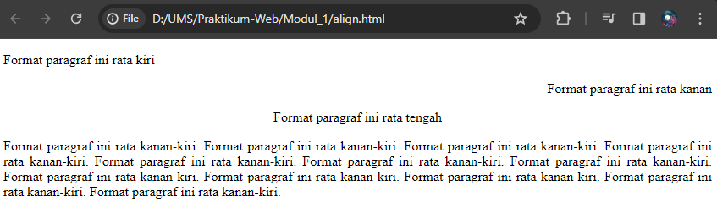

1. **Experiment 5 (Picture)**

* Code

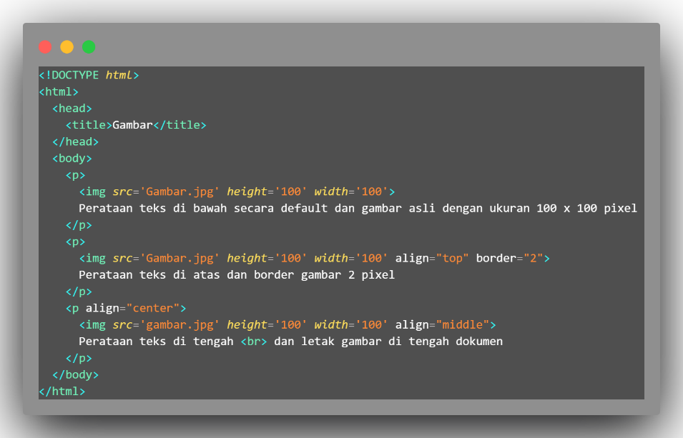

* Result

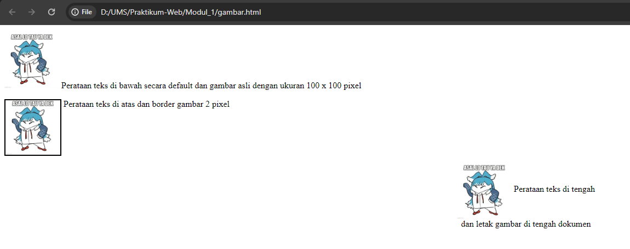

1. **Experiment 6 (List using Bullets and Numbering)**

* Code

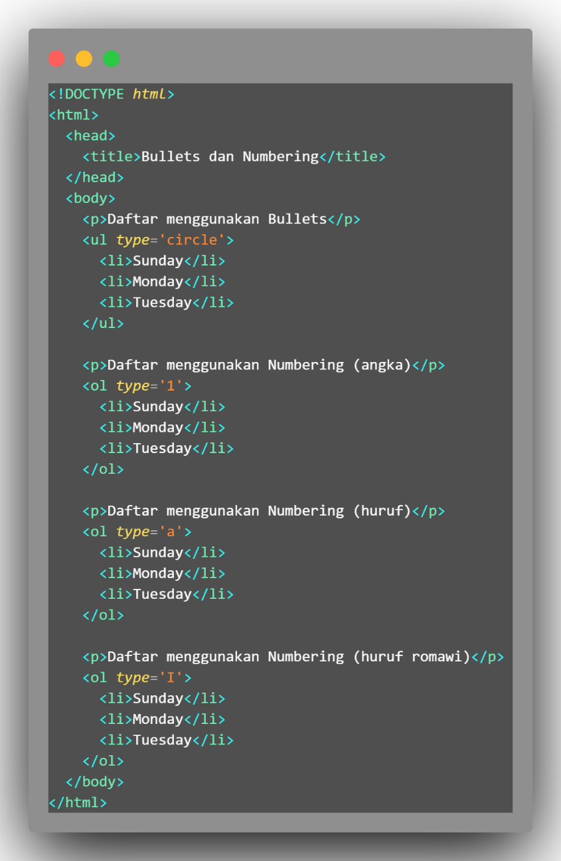

* Result

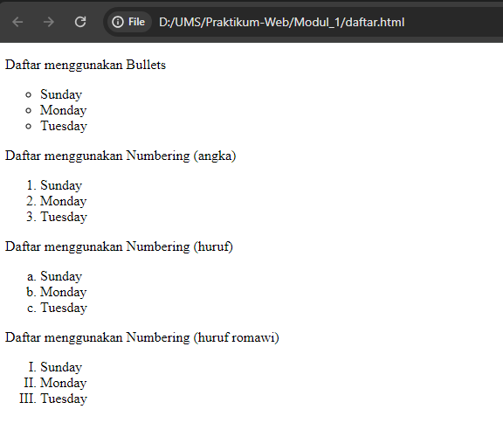

1. **Experiment 7 (Table)**

* Code

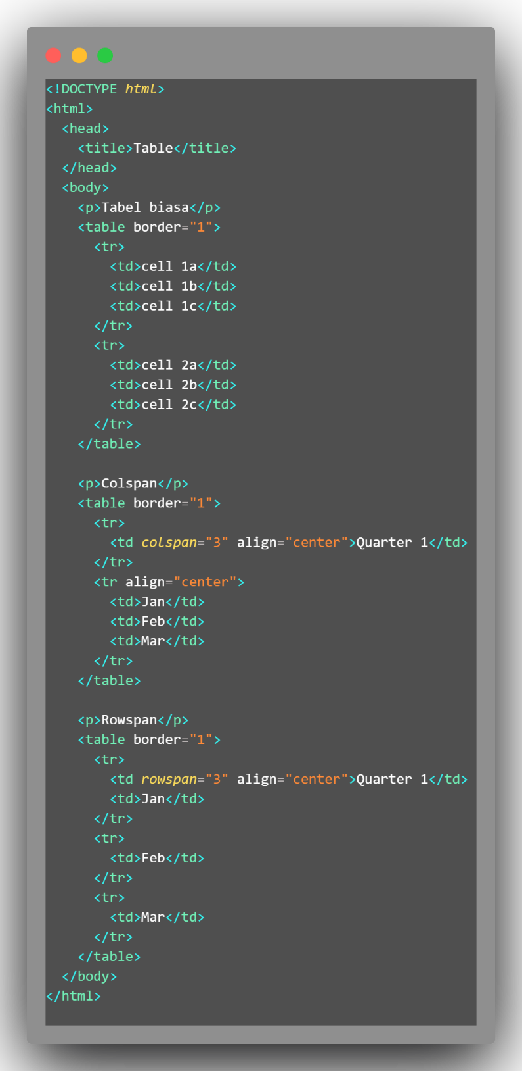

* Result

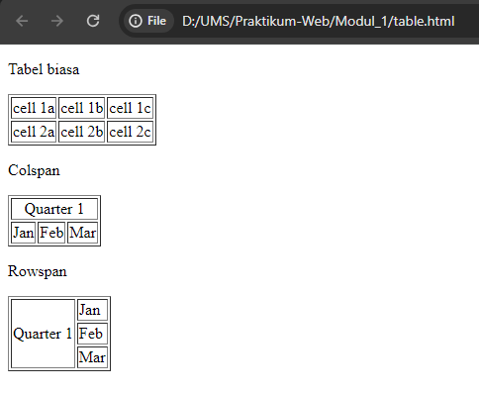

**ASSIGNMENT**

1. Write an HTML script to create the content as shown in Figure below with the background document of an image ﬁle. The name of the image ﬁle used is your NIM. Then print the result screen and attach it to your report.

* Code

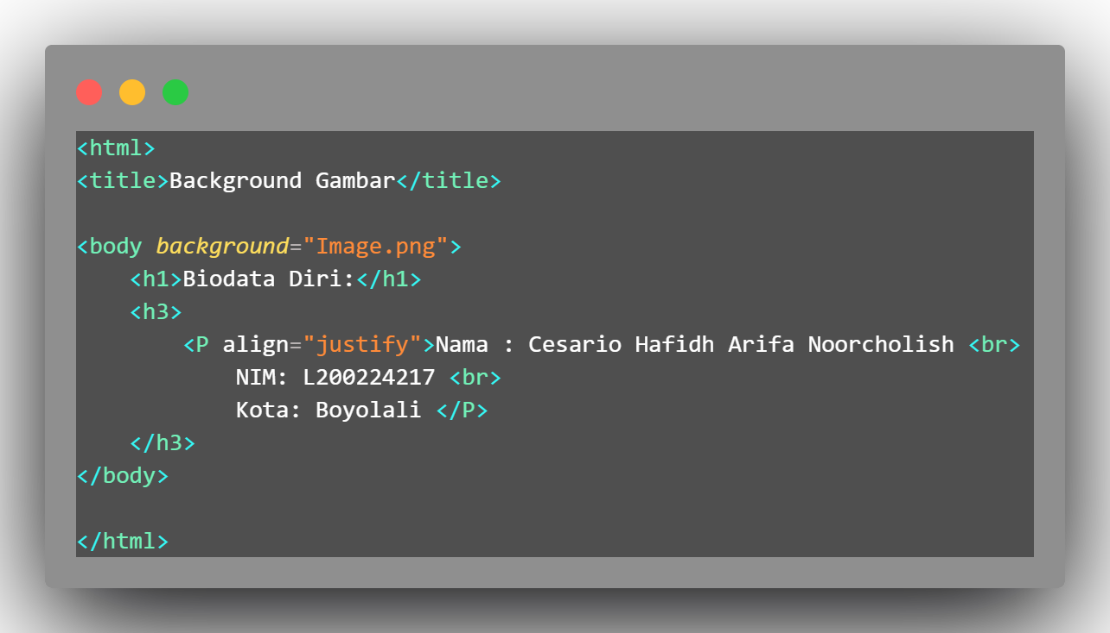

* Result

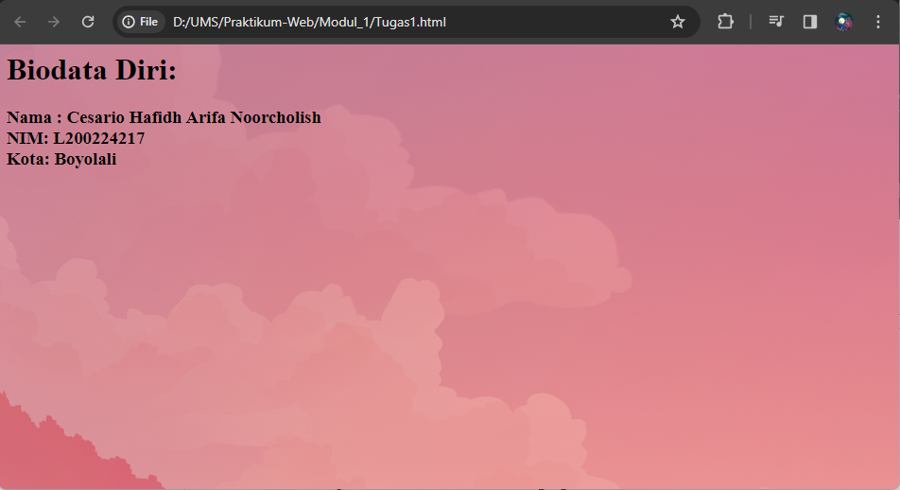

1. Explain the function of the following tags or attributes:

|  |  |  |
| --- | --- | --- |
| No | Tag/Attribute | Function |
| 1 | bgcolor='blue' | Sets background color |
| 2 | <h1> - <h6> | Heading levels 1 to 6 |
| 3 | <font>...</font> | Sets font properties |
| 4 | face='verdana' | Sets font face |
| 5 | size='10' | Sets font size |
| 6 | color='blue' | Sets text color |
| 7 | <b> </b> | Bold text |
| 8 | <i> </I> | Italic text |
| 9 | <u>...</u> | Underlined text |
| 10 | <strike>...</strike> | Strikethrough text |
| 11 | <sup>...</sup> | Superscript text |
| 12 | <sub>...</sub> | Subscript text |
| 13 | <p>...</p> | Paragraph |
| 14 | align='center' | Aligns content to the center |
| 15 | <img> | Image |
| 16 | src='gambar.jpg' | Image source |
| 17 | width='100' | Sets image width |
| 18 | height='100' | Sets image height |
| 19 | alt='alt' | Alternative text for image |
| 20 | <ul>...</ul> | Unordered list |
| 21 | <ol>...</ol> | Ordered list |
| 22 | <li>...</li> | List item |
| 23 | type='circle' | List type (circle) |
| 24 | <table>...</table> | Table |
| 25 | <tr>...</tr> | Table row |
| 26 | <td>...</td> | Table cell |
| 27 | border='2px' | Table border width |
| 28 | colspan='2' | Span multiple columns |
| 29 | rowspan='2' | Span multiple rows |
| 30 | </BR> | Line break |